CEDARBRAE C.I.’S MODEL UN

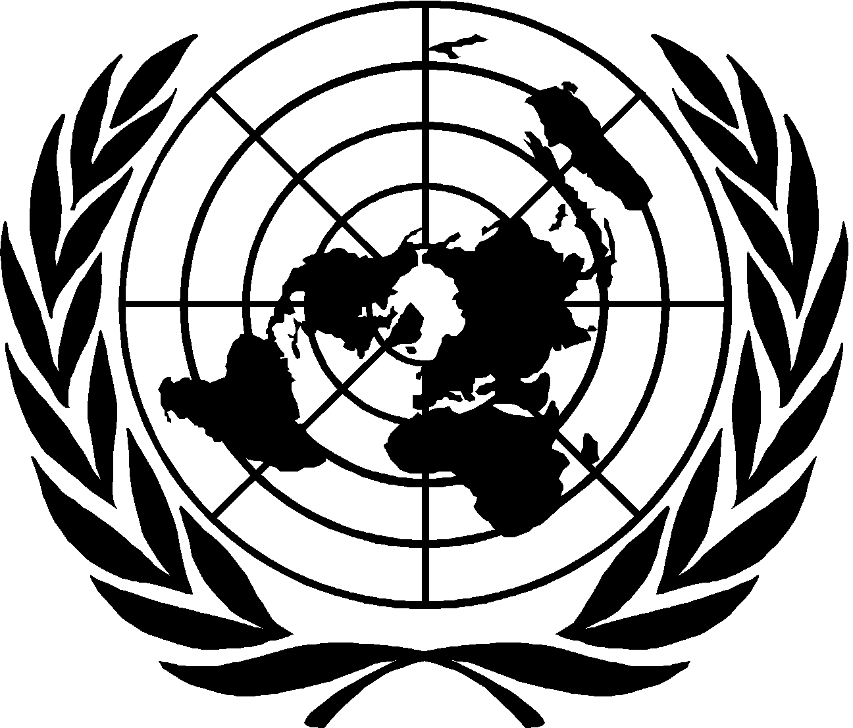

COP

Adrian Harris Inshaal Qadir

April, 2015|Cedarbrae Collegiate Institute
Greetings delegates,

My name is Inshaal Qadir and it is my distinct pleasure as both, the Information Officer and as the co-chair of the COP committee to welcome you all to the first annual Cedarbrae Collegiate Institute Model United Nations Conference. I am currently a junior at CCI and with this being my first time being a part of Model United Nations at our school, I firmly believe it is among the greatest choices I’ve made as far as extracurricular activities go. In my free time, I like to play hockey, read, learn programing languages, and discover unique places around the city.

I believe that participating in Model United Nations is one of the most beneficial, worthwhile and rewarding experiences. Not only is it a source of insight into pressing global issues, but it also provides delegates a chance to hone their communication skills, and builds in them the art of diplomacy, which are skills you can use for the rest of your life.

Undoubtedly, CCIMUN is one conference that promises much and will deliver it. This is something you would not want to miss!

I look forward to seeing you in April! Best of luck!

Sincerely,
Inshaal Qadir

Topic 1: Climate Change Refugees – Adrian Harris
Introduction
Climate change refugees are refugees that are forced to leave their homes and communities because of the negative effects of climate change. For example, coastal cities and communities are under threat of being submerged by rising sea levels. In addition, rising temperatures are leading to droughts and arable land becoming desert. Climate change refugees are under the category of environmental refugees. One of the largest problems concerning climate refugees is that environmental refugees are not protected by international laws that protect traditional refugees such as political refugees.
Rising Sea Levels
Many predictions say the planet’s sea levels will rise to between 2.5 and 6.5 feet by 2100. It is estimated that 1.7 million people in the Pacific islands alone will be displaced due to climate change by 2050. There are many different aspects that have to be considered with the rise of sea levels. For instance, the gradual loss of land resulting in economic and political problems, and the many effects of natural disasters caused by rising sea levels such as floods and storm surges.
Several island nations are in danger of being submerged to the point of them becoming inhospitable with rising sea levels. In particular, the Republic of Kiribati, which is located between Hawaii and Australia, consists of one raised island and 32 atolls most of the island nation isn’t more than 3 meters above sea level. It has a population of 102, 697 people and is slowly being submerged.
In addition, the Maldives is made up of over 1,100 islands and it is located west of India. The majority of the islands are only 1.3 meters above sea level. The Maldives has a population of around 325,000 and 100,000 non-resident workers.
Also, the Seychelles has 115 coral and granite islands located in the western Indian Ocean. Seychelles currently has a population of 87,122 people and most of the islands don’t raise higher than three feet above sea level.
Similarly, the Solomon Islands are a group of islands that are found east of Papua New Guinea. The population of the island chain is 584,578 on average the islands are around 6-10 feet above sea levels. The majority of the population relies on agriculture which is being threatened by the encroaching sea.
Bangladesh and countries similar that coasts are slightly above sea level and suffer from serious floods are also enduring the effects of rising sea levels. Floods and storm surges are common in the country and are intensified by the effects of climate change. In addition the scenarios have been calculated to predict how sea level rise will affect the country in the future. The total population currently around 159,000,000 and has a total land area of 134,000 km². It has been simulated that at a rise of 1.5 meters the ocean will consume the coast of the country affecting 22,000 km² of lane and 15% of the population in only 150 years. Displacing around 23,850,000 people.
Drought and Desertification
While, the rise of sea levels endangers people on Islands and coastal regions, drought is creating refugees inland. When people in a region can no longer grow crops in an area that was once fertile due to climate change they are forced to move somewhere else in order to survive creating refugees. As a result, this not only destabilizes the local economy due to the loss of the agricultural industry and the crisis on food but this also affects the country’s exports and the countries who were once receiving the goods. There is not only the threat of drought but, also desertification which is a dry land region losing its vegetation and bodies of water because of the degradation of the land. Desertification affects around 168 countries worldwide.
In 2011 on June 30th the United Nations reported that the largest refugee camp in the world at the time, located in Kenya, was being over populated due to a regional drought in the area. The amount of refugees at the camp at the time of the report was 353,921 people - four times over its capacity. It was estimated that 10 million people across the Horn of Africa faced this severe food crisis.
The Gobi desert, which is located in the north of China, expands more than 3,600 km² every year consuming surrounding grasslands. As a result, farmers and merchants in the region are forced to migrate further into China’s crowded urban areas. Tunisia, Morocco, Libya have more than 1,000 km² of productive land destroyed by desertification. Because they are on the edge of the Sahara Desert they may migrate to regions of northwest Africa or attempt to go to a more developed country such as Europe.
Places Most At Risk
Currently, there are around 2.8 billion live in places that are under high risk of being affected by the negative effects of climate change such as storms, floods droughts, sea level rise, and desertification. A large majority of places that seeing the extreme effects of climate change are in poorer or developing countries. There is a high probability most refugees escaping from life-threatening weather conditions will be from Asia and Africa. Not only will Asia see the effects of sea level rise but they’ll also suffer from severe droughts. Africa is also under the threat of seeing the results of water scarcity and drought. In addition many regions such as Latin America and a large amount of small islands will see the negative effects of sea level rise.
Refugee Status
Currently people displaced from their homes due to climate change aren’t protected or even recognized by international bodies such as the UN. Most countries have no separate policy when it comes to migration due to climate change. Climate change refugees who seek refuge are under a greater risk of being sent back to their destroyed homeland unlike political or oppressed refugees. Because of this most refugees have to migrate internally which may result in a sudden flux of population that puts stress on the current infrastructure of that country. It is clear that climate change may also increase the number of traditional refugees due to the fact the scarcity of resources like water and food will become even more scarce causing conflict.
Focus Questions:
1. How will countries deal with the large amount of displaced people due to climate change?
2. What is the most effective approach for solving the problem trying to reduce the effects of climate change or trying to build the infrastructure to support the displaced people?
3. Most countries don’t see climate change refugees as an immediate threat to the world so for the minority of countries being largely effected how will you build awareness?
Useful Links:
http://ocean.nationalgeographic.com/ocean/critical-issues-sea-level-rise/
http://earthreform.org/mass-migration-the-untold-crisis-of-climate-refugees/
http://www.un.org/apps/news/story.asp?NewsID=38904#.VKfssyvF95Y
http://education.nationalgeographic.com/education/encyclopedia/climate-refugee/?ar_a=1
http://www.unccd.int/en/Pages/default.aspx
http://www.un.org/en/

Bibliography
Astaiza, Randy. "11 Islands That Will Vanish When Sea Levels Rise." Business Insider. Business Insider, Inc, 12 Oct. 2012. Web. 26 Dec. 2014. <http://www.businessinsider.com/islands-threatened-by-climate-change-2012-10?op=1>.
"Climate Refugee." Http://education.nationalgeographic.com. Web. 25 Dec. 2014. <http://education.nationalgeographic.com/education/encyclopedia/climate-refugee/?ar_a=1>.
"Sea Level Rise." Http://ocean.nationalgeographic.com. Web. 27 Dec. 2014. <http://ocean.nationalgeographic.com/ocean/critical-issues-sea-level-rise/>.
Wilson, Catherine. "Climate-threatened Solomon Islanders Prepare for Evacuation." Climate-threatened Solomon Islanders Prepare for Evacuation. 25 Nov. 2013. Web. 27 Dec. 2014. <http://www.trust.org/item/20131125112530-1wkla/?source=dpMostPopular>.
"Potential Impact of Sea-level Rise on Bangladesh." Http://www.grida.no/. Web. 26 Dec. 2014. <http://www.grida.no/publications/vg/climate/page/3086.aspx>.
"Regional Drought Causing 'alarming' Overcrowding at Kenyan Refugee Camp: UN." UN News Center. UN, 30 June 2011. Web. 27 Dec. 2014. <http://www.un.org/apps/news/story.asp?NewsID=38904#.VKqAFyvF95Z>.
Sultan, Anam. "Mass Migration: The Untold Crisis of Climate Refugees." Earth Reform RSS. 4 Aug. 2012. Web. 27 Dec. 2014. <http://earthreform.org/mass-migration-the-untold-crisis-of-climate-refugees/>.

Topic 2: Development of Oil Sands – Inshaal Qadir
Introduction
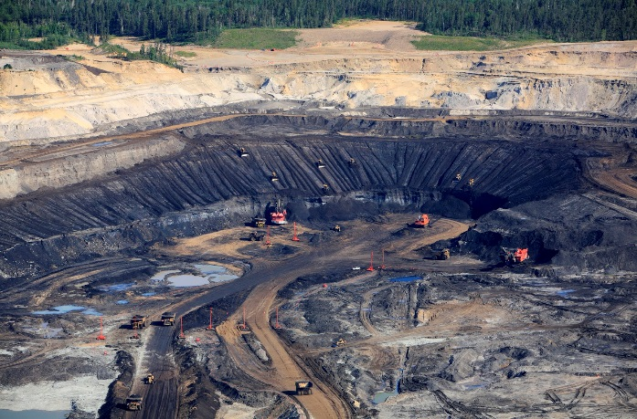
The importance of oil in our society is so substantial that it affects developed and developing countries. It is a huge contributor to economic growth and environmental destruction. It is acknowledged that oil will not last eternally. Global demand has been rising and is expected to continue to do so in the future. Major conventional oil discoveries are declining. These issues have brought our current oil dependent way of life up for debate. On one end are those who view this as a sign to move toward alternative energy sources (i.e. solar and wind power), and on the other end are the optimists who believe that the oil is far from over. There is hope that more oil will be discovered and that the technology advances will provide the opportunity to develop unconventional sources of oil.

Oil Sands
One of the unconventional sources are oil sands. While oil from conventional sources is relatively easy to extract, the extraction from oil sands has a complicated process. Bitumen is a thick and extremely viscous oil present in the oil sands. Due to its thick layer, it needs to be heated or mixed with lighter hydrocarbons to be able to flow like oil. Oil sands contain about 10-12 percent bitumen, 83-85 percent sand and clay, and 4-6 percent water. There are two processes involved to create this mixture: to separate the bitumen from the clay and sand, and to upgrade the bitumen to crude oil that can be sent to refineries. Approximately two tons of bitumen mixture to produces one barrel of oil. However, this method is only applicable to a small amount near the surface. Most of the bitumen mixture is located far underground and requires much more complicated, in-situ drilling methods. “In-situ methods require that a series of wells are built so that the bitumen can be reached and treated, for instance with steam, so that it can flow to the surface like regular oil.”
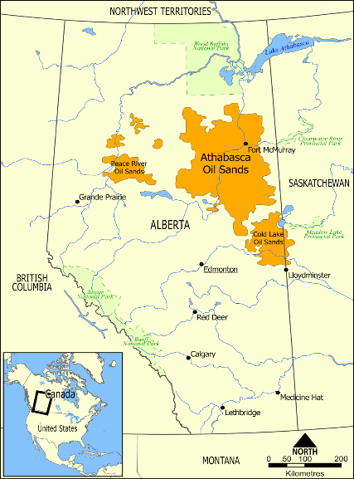
Alberta’s Oil Sands
Alberta stands as a long-time oil-producing province; it is one of the two largest areas of oil sands worldwide. While first discovered in 1778, Canada’s oil sands lay undeveloped until not long ago due to technological and economic barriers; it was not worth investing in oil sands while there were many alternative sources of oil that are easy and cheap to reach. The first mine development was in 1967 by Suncor Energy, the second mine was developed by the Syncrude consortium in 1978 and the third mine developed in 2003 in the Athabasca Oil Sands by the Albian Sands consortium of Shell Canada, Chevron Corporation, and Western Oil Sands Inc. It was a relatively expensive process which cost 23 dollars per barrel. Several factors have recently led to a large expansion of interest in the Alberta oil sands. One of them to be that the conventional sources of oil in western Canada have been declining. Advances in technology have also led to cheaper and easier methods of extracting the oil. In addition, world oil prices have risen, which makes development of the Canadian oil sands a much more viable prospect. Canada now produces twice as much from its oil sands as it did a few years ago, and is expected to rise in the future.

Environmental Concerns
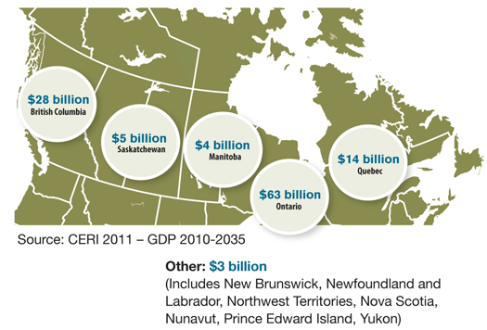
As with the oil industry in general, many environmental concerns have rose in response to oil sands development. Infrastructure development (i.e. roads, bridges, utilities, housing for workers, pipelines etc.) means stripping the land from its natural habitat. One of the most important environmental issues surrounding the oil sands is their wide use of resources and their contribution to greenhouse gas emissions. According to Elizabeth May, executive director of the Sierra Club of Canada, "Tar sands oil is to conventional oil what crack cocaine is to ordinary cocaine powder". Oil sand development needs more energy than regular oil production because of the complicated processes needed to not only extract the oil from the ground but also to produce the hydrogen needed to upgrade the heavy crude and heat the water used to separate the oil from the clay/sand. All of these actions needed produce green house gas (GHG) emissions such as CO2 which is a contributing factor to climate change. Oil sands account for 8.7% of Canada’s GHG emissions and just over 0.13% of global GHG emissions (Environment Canada 2014). “Each barrel of oil requires two to five barrels of water, carves up four tons of earth, uses enough natural gas to heat a home for one to five days, and adds to the greenhouse gases slowly cooking the planet, according to the industry's own calculations”. As the oil sands industry grows, the demand on Canada’s water resources does as well. Water is an important aspect in the mining operations of oil sands since warm water is used to separate the bitumen from the sand and clay. It is also used in drilling of in situ wells and in worksite camps for oil sands operations. A significant amount of wildlife species are affected by oil sands development activities from the disturbances to their habitats. Operations disrupt the habitat of a plants and animals, for instance by clearing land for well sites or mining. ‘Linear developments such as roads, cutlines and pipeline rights-of-way can affect wildlife by creating travel corridors for predators such as wolves.’ The main benefits of developing oil sands are mostly economic. The oil sands currently provide 514,000 jobs for people across Canada. There is less dependence on unstable foreign sources of oil which allows Canada to maintain their current oil dependent way of life. However, the drawbacks of oil sands development are quite serious environmentally.
Economic benefits generated over next 25 years – provinces outside of Alberta
Focus Questions
- How can green house gas emissions be reduced in the development of oil sands?
- Were there any resolutions proposed in the past? Can we find a way to effectively make them work?
- Can heavy oil avert an energy crisis?
- Should there be stringent policies for oil sands? If so, what policies can your country propose?
- Currently only a small fraction of the Earth's unconventional oil has been tapped. Could the reason be the lack of necessary capital, technology and expertise some countries have?

Useful links:
http://thetyee.ca/News/2010/09/09/OilSandsWorld/
http://www.oilsandstoday.ca/Pages/default.aspx
http://www.macleans.ca/economy/economicanalysis/the-harper-government-is-doing-more-harm-than-good-for-the-oil-sands/
Sources
"Economic Contribution." Oil Sands Today. N.p., n.d. Web. <http://www.oilsandstoday.ca/ENERGYECONENVIRON/Pages/EconomicContribution.aspx>.
"GHG Emissions." Oil Sands Today. N.p., n.d. Web. <http://www.oilsandstoday.ca/topics/ghgemissions/Pages/default.aspx>.
"Fort McMurray Oil Sands." In Alberta, Canada. N.p., n.d. Web. <http://www.fortmcmurrayonline.com/oilsands/welcome.aspx>.
"Environmental Health Risks of Alberta Oil Sands Likely Underestimated: Study." The Globe and Mail. N.p., n.d. Web. <http://www.theglobeandmail.com/news/national/environmental-health-risks-of-alberta-oilsands-probably-underestimated-study/article16667569/>.
"Bitumen." The Canadian Encyclopedia. N.p., n.d. Web. <http://www.thecanadianencyclopedia.ca/en/article/bitumen/>.
"Pipeline Through Paradise: Big Oil's Plan to Tap the Arctic." Mother Jones. N.p., n.d. Web. <http://www.motherjones.com/politics/2007/10/pipeline-through-paradise-big-oils-plan-tap-arctic>.

