CEDARBRAE C.I.
MODEL UN 2015

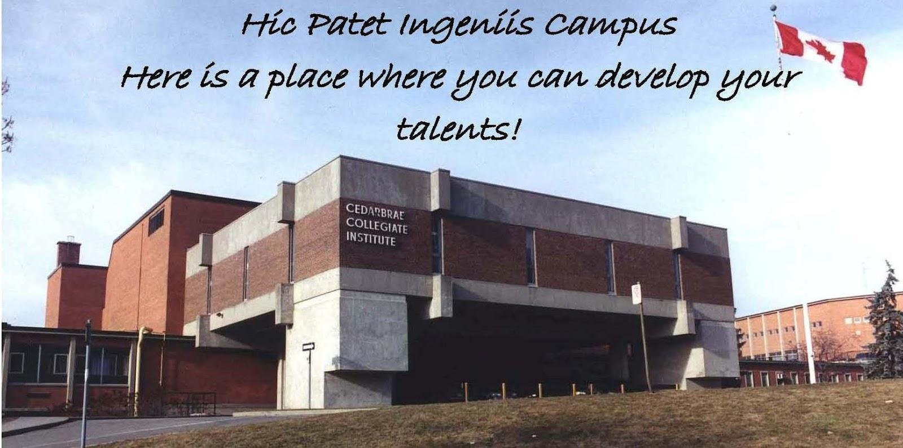
April 24th, 2015

CHAIRS:
NOOR ALI & EMILY STANDISH

CCIMUN 2015:

DOCTOR WHO
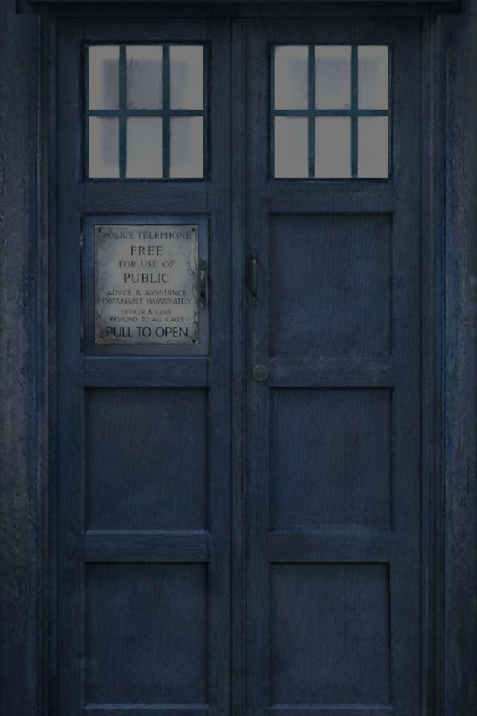

TABLES OF CONTENTS
Greetings from the Chairpersons | Page 1 – 2
DOCTOR WHO? | Page 3
First Crisis Topic Info | Page 4
First Crisis Topic | Page 5
Second Crisis Topic Info | Page 6
Second Crisis Topic | Page 7
Third Crisis Topic Info | Page 8
Third Crisis Topic | Page 9
Roles | Page 10 -13
Guide Questions for Delegates | Page 14
Resources/References | Page 14

GREETINGS FROM THE CHAIRS

Hey fellow Whovians,
*Fixes bow-tie* My name is Noor Ali and I will be one of your chairpersons for this Doctor Who Committee. I have great knowledge about the Doctor Who Universe and I would be honoured to lead our discussions that we'll soon be participating about. Some personal stuff: I'm a friendly and inclusive person, I like longs walks on the beach. And I also overuse a lot of my jokes, so I apologize in advance. I admit that my phone's ring tone is the 11th Doctor's theme. But besides Doctor Who I also fancy watching Sherlock, both shows go great together. If you don't watch Sherlock, you're missing out on a lot! Other than watching British T.V. Shows, I watch a ton of YouTube channels that help me procrastinate from doing my homework. (I spend more time complaining about how much homework I have than actually working on it). Other than that, I really hope this committee goes well for everyone and grows into a passionate and friendly environment. Welcome to the Doctor Who Committee. ALLONS-Y!

Hey, my name is Emily Standish and I'm one of the co-chairs for the MUN Doctor Who Committee. To be honest with you, I haven't seen much of the older Doctor Who mainly because it's not on Netflix. However, I'm out to date on the newer seasons. What to tell you about myself? Well for one, I'm probably one of the weirdest fangirls you may ever meet (Being SuperWhoLocked does that to a person). I'm able to both read and write Gallifreyan, the written langue of the Time Lords. I am very excited to be chairing this committee and being able to meet all of you and be able to share a common interest or maybe more if you are (like myself) in many fandoms. I hope that this background guide is very helpful to everyone that will be taking part in our committee. I hope that our committee will be the best one at the conference. Fantastic! Allons-y! and Geronimo!

1
DOCTOR WHO?

The Doctor is a renegade Time Lord. An alien from the planet Gallifrey who travels in a time-machine alongside a companion(s) through time and space. He has influenced and changed many historical events. The Doctor does not use brute force nor weapons (unless you count a sonic screwdriver as a weapon) but rather just his mind and creativity to solve problems he faces and rise above his enemies. He is able to regenerate when needed which when he does causes his body and personality to change. As of now we have the Twelfth version of the Doctor running around in the Universe (excluding the War Doctor).

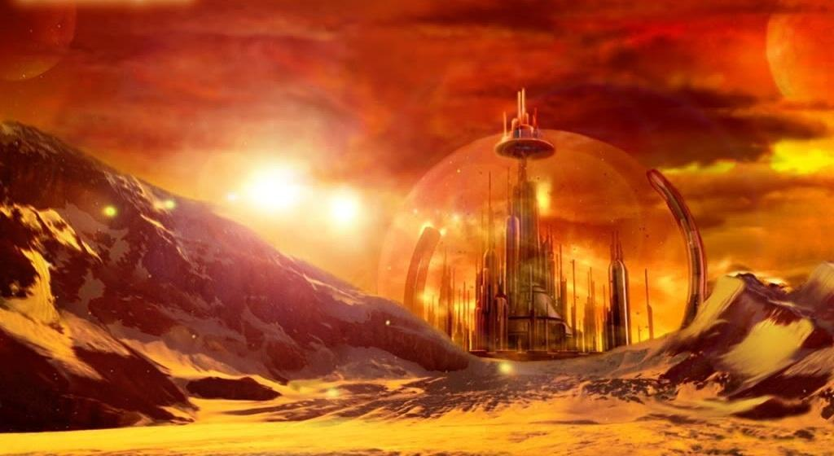

This is the Doctor's home, Gallifrey.

WELCOME DELEGATES

How did you all get here?

As the twelfth Doctor and Clara were about to travel to the Eye of Orion, passing through the time vortex, they landed and opened the TARDIS's doors looking outside and realized that they were actually somewhere else. There were 12 other blue boxes laying right before them in a semi-circle. In the middle there was UNIT officials, River Song, two Oods, an elite from the 39th century human colony, Rassilon and The Chancellor, and 12 other Doctors and 14 other Companions. At last, a being that had gears and sprockets on its body with a metallic face and golden eyes, calling itself the Moment. All these people were called because all of them are tied to an event that'll change space and time. The Moment managed to get these people from ruptures in time and space, which explains how it got all incarnations of The Doctor.

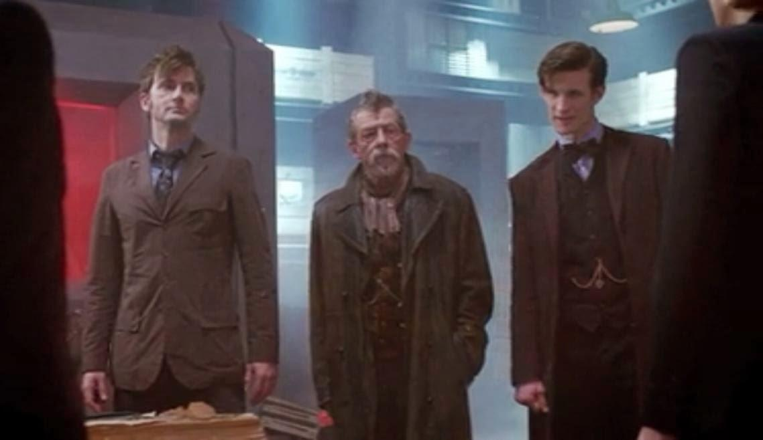

Crisis Topic:
Odd Moon of the Ood

As time went on, humans embraced the life that was outside of Earth. They started colonizing many different planets and moons. The 39th century human colonist had landed on a moon called the Ood-Sphere. This was the home-world of the peaceful Ood. The Ood-Sphere was one of the moons of a ringed planet. The buildings and structures were made of ice. The Moon was covered in mountains and cliffs.

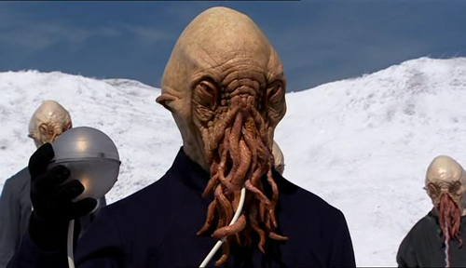
These are the Ood, as scary these may look the Ood are a peaceful, telepathic species but their telepathy is very weak against outside forces. The sphere is connected to the Ood via a tube connecting their external brains to their body.

CRISIS TOPIC:
Odd Moon of the Ood
Delegates: As you continue reading the situation you must find out and say what should happen next. Every bit of information is important.

The Doctors received a distress signal from the icy world of Ood. They find out that humans who have colonized the moon are going through some trouble. A special energy only found on this moon is destabilizing and the humans don't know how to fix it. The Doctors find out the distress signal is both from the Ood and the humans who came along after to colonize. The Ood have had their freedom and land taken away by humans. The only way to find this energy is by using the Ood's hive mind because they are all connected to the Ood Brain.
As the Doctors investigate, the humans urge the Doctors to go away because they think they can handle it. The Doctors do not listen but later one of the companions ends up being mind controlled by an Ood and are forced to attack other Companions/Doctors, the Doctors stop it fortunately. Humans use this incident to show proof that they themselves are doing nothing wrong. The Ood Brain would be no where to be found. The Doctors call any officials of the colony of humans and two Oods for an intervention.
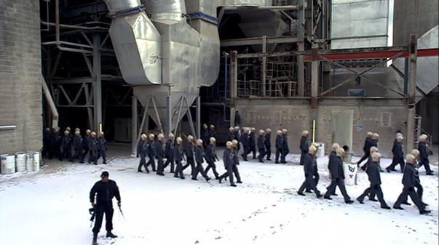

On the left is a human colonist, controlling the actions of the Ood. The humans have immense power over theOod.

CRISIS TOPIC:
UNIT UPRISING

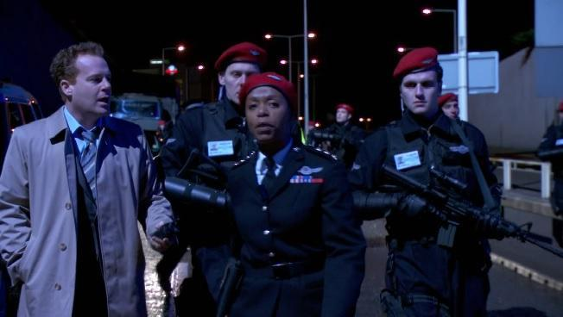

UNIT (Unified Intelligence Taskforce) is a military organization that is specialized to research and combat extraterrestrial threats to Earth. The Doctor worked closely with them before but as the organization changed its views, the relationship between the two has become unstable.

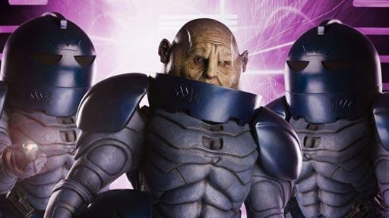

The Sontarans are a fierce species that do not fear death, in fact they welcome it. They are tough soldiers that do not reproduce sexually meaning that they are clones. The Doctor has faced the Sontarans many times. They almost ended up taking over Earth and defeating the Doctor. The Doctor refers to them as “one of the finest solider in the Universe”.

UNIT UPRISING
Delegates: As you continue reading the situation you must find out and say what should happen next. Every bit of information is important.
UNIT has decided to build up defences in case of a future alien threat towards Earth. UNIT out of desperation has begun to search the Earth for any alien technology from any events of the Doctors facing their enemies and even build an alliance with the belligerent Sontaran for their amazing war expertise. After recording memorable fights between the Doctors and their enemies, UNIT is now trying to build a powerful and secret arsenal. This is a very risky move from UNIT because of how little they know about the weapons/technology they are finding. Also, the Sontaran are unreliable as they have tried invading Earth before. If UNIT manages to get these weapons and build a strong force with the Doctor then the Doctor may be in trouble if dealing with future conflicts. But, This is what UNIT has found for now:
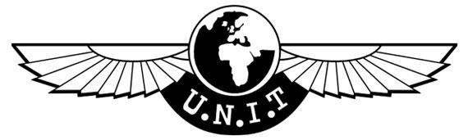
First Doctor:
Episode: The Dalek Invasion of Earth
Item found: Dalekanium
Second Doctor:
Episode: The Moonbase
Item found: Gravitron
Third Doctor:
Episode: The Chase
Item found: TARDIS Compass
Ninth Doctor:
Episode: The Doctor Dances
Item found: Nanogenes
Tenth Doctor:
Episode: Doomsday
Item found: Cybermen technology/blueprints
Eleventh Doctor:
Episode: The Pandorica Opens
Item found: The Pandorica
Twelfth Doctor:
Episode: In the Forest of the Night
Item found: TARDIS GPS

CRISIS TOPIC:
TIME OF THE DOCTOR

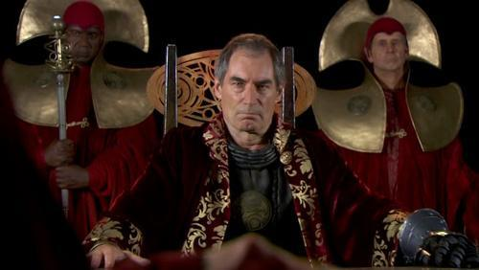

Rassilon was the founder and leader of the Time Lord civilization. He is the lord president of the Time Lords. Rassilon was known as being a goodhearted leader who cared for his people. But near the end of the Time-War he become vicious and bent on staying alive even if it meant to destroy the rest of the Universe.

TIME OF THE DOCTOR

After the interventions, Rassilon believed that the Doctor's time is over. That he must die due to the crimes he has committed. The Moment will allow it if Rassilon can list examples as to why. The Doctors and Companions should prove the opposite. They should list the amount of times the Doctor had helped the Universe and why it still needs him in order to convince the Moment and Rassilon. Each companion can only help their version of the Doctor that they were with. But! The War Doctor should list reasons why Rassilon should step down.

CHARACTER ROLES
Susan Foreman( First Doctor )- She is a pupil at Coal Hill School where she was taught History by Mr. Wright and Science by Mr. Chesterton. She is also the First Doctor's granddaughter and Companion. She is curious, quick-witted and kind, as well as the first companion to leave the Doctor to settle with David Campbell after stoping a Dalek invasion of Earth.
Jamie McCrimmon( Second Doctor )- James Robert McCrimmon or Jamie was a piper and soldier, fighting the hated English at Culloden in 1746. After escaping his execution, he follows the Doctor into the TARDIS. Though he lacked intelligence, he more than made up for it in strength, charm and instinct. He had his memories erased, and returned to Scotland the day he left by the Timelords during the Doctor's trial.
The Brigadier( Solo )- Colonel - later Brigadier - Alistair Gordon Lethbridge Stewart was the commanding officer of UNIT. He first met the Second Doctor when he helped free London from the Great Intelligence and the Cybermen. When the Third Doctor was exiled to Earth, he became UNIT's unofficial scientific advisor, giving The Brigadier much needed information on the aliens that attacked Earth. He retired from UNIT and taught at a boarding school but he didn't finally settled down with his wife in till after helping the Seventh Doctor vanquish Morgaine. He later died in his sleep during the Doctor's eleventh incarnation.
Jo Grant( Third Doctor )- She might have failed her science exams, but she was still hired by UNIT as the Doctor's lab assistant. For what she lacked in scientific intelligence, she made up for in bravery and heart. She faced the Master numerous amount of times, was proposed to by the King of Peladon, and went to find help on Spiridon when the Doctor had been shot. She finally left the Doctor and TARDIS to marry Clifford Jones, and become an environmentalist activist. She attended the Eleventh Doctor's "funeral", teamed up with Sarah Jane Smith to free the Doctor.
Sarah Jane Smith( Fourth Doctor )- During her investigating of the disappearance of UNIT scientist, she stows away on the Third Doctor's TARDIS, and taken to the Middle Ages. After the Third Doctor's regeneration, she travelled with the Fourth Doctor. After being possessed by Eldrad, she told the Doctor that she was “sick of being shot at, savaged by bug-eyed monsters”. As a result of this, the Doctor dropped her back on Earth, but not in South Croydon as she wanted. She later meets up this the Tenth Doctor at Deffry Vale School and helping in the defeat of the Krillitanes. She begins to investigate alien disturbances from her home on Bannerman Road. After building up a family with her adopted son Luke and his friends, she took on Sontarans, Androvax and the Trickster.
Tegan( Fifth Doctor )- On her way to Heathrow Airport for her first day as an air stewardess, her car gets damaged. Upon entering a Police Phone Box, she steps on to the alien world of Logopolis and witnesses the Fourth Doctor's regeneration. Her mind ended up being host to an evil snake-like parasite called the Mara. It attempted twice to use Tegan as a conduit to return to corporeal form. Always forthright and often difficult, Tegan bade the Doctor and Turlough an emotional farewell after preventing the Daleks from arriving in 1980s London. Sarah Jane Smith said she had become a campaigner for Aboriginal rights in Australia.
Peri Brown( Sixth Doctor )- Perpugilliam “Peri” Brown, met the Fifth Doctor while on her stepfather's archaeological dig in Lanzarote. After helping to defeat the Master, she began her travels with the Doctor. During their early adventures, they contract Spectrox Toxaemia on Androzani Minor and due to the Doctor's selfless actions, saves her from death but also prompting his regeneration. At first, the Sixth Doctor was unstable, making it hard for Peri to come to terms with him. During the Doctor's trial, it was revealed that Peri had died on Thoros Beta, which turned out to be false, as she actually was alive and married to Yrcanos.
Ace( Seventh Doctor )- Being from 1980s London, Dorothy aka Ace, was a troubled teen who met the Doctor on Iceworld, when she was teleported there as a part of a trap by an ancient evil called Fenric. Preferring to use home-made explosives, a baseball bat and her ghetto-blaster. Being able to fight Daleks and Cybermen single-handedly, faced the demons of her past and the reality of her hatred towards her mother. She was righteous and brave, and had absolute faith in the Doctor. She even developed into a bold young woman during her travels. There are many conflicting reports about what happened to her, but Sarah Jane Smith recalled that a "Dorothy something" had raised millions of dollars through her foundation A Charitable Earth.
Grace Holloway( Eighth Doctor )- An eminent cardiologist, Dr. Grace Holloway's life changed when she lost a surgical probe in a man's chest resulting in his death. She remained adamant that the man's cardiovascular system was not normal, and resigned from her post. On her way out, she ran into a confused younger man with the same prob in his chest. Eventually believing that he was an alien that could change his face, Grace helps the newly regenerated Eight Doctor against the Master by "jump starting" the TARDIS and roll back the effects of the open Eye of Harmony. She shared a kiss with him at the turn of the millennium but refused a chance to travel with him but offering that he stay with her.
Rose Tyler( Ninth Doctor )- After being trapped by the Autons in the basement of the department where she worked, Rose was saved by having a chance encounter with the Ninth Doctor. When her heroism leads to the defeat of the Nestene, she takes the Doctor's offer to join him on his travels. Throughout their travels, no matter how dangerous, she told the Doctor that she would stay with him forever. (When she looks into the Heart of the TARDIS, she becomes Bad Wolf) After causing and witnessing the Ninth Doctor regenerate, their bond becomes even stronger. During the Battle of Canary Wharf, she is sent into a parallel. Using a Dimension Cannon, she attempts multiple times to contact the Doctor and Donna. Finally encountering him when he gets exterminated by a Dalek. Once healed and Daleks gone from Earth, the Doctor returns Rose to her family in the parallel dimension with a half Human-half Timelord version of himself.
Captain Jack( Solo )- Being a Time Agent, Head of Torchwood, and the Poster Boy for the Boeshane Peninsula. Captain Jack Harkness has been many things in his long life. After first meeting Rose and the Ninth Doctor in 1940s London, he helped the Doctor defeat the "Empty Child" and the Slitheen before being exterminated by the Daleks on the Game Station. However he is revived by Rose Tyler or Bad Wolf and made immortal. After leaving the Game Station, he travels to 1869, when his Time Vortext breaks, making him have to live through the twentieth century. He joined Torchwood in Cardiff, knowing that one day the Doctor would return.
Martha Jones( Tenth Doctor )- Studying for her doctorate in medicine, she was in the Royal Hope Hospital when the hospital was teleported to the moon. She showed great bravery in the face of the Plasmavore, which caused the Doctor to ask her to join him on his adventures. Towards the end of their adventures, the Doctor gets captured by the Master. During this time, Martha travels around the world, telling everyone she meets stories of resistance of the Doctor. The psychic energy gathered by this freed the Doctor and stopped the Master's plans. She leaves the Doctor once the world returns to the way it was. She is the one who activates Project Indigo in the face of the Reality Bomb and afterwards marries Mickey Smith, and together they hunt alien threats on Earth.
Donna Noble( Tenth Doctor )- Working as a temp, before getting swept away in the TARDIS on her wedding day. She was saved by the Doctor before she could get married to Lance, a co-worker that had made a deal with Empress of the Racnoss. After turning down the Doctor's offer to join him on the TARDIS, she begins to look into other alien incursions, in hopes that she will meet him again. They finally meet again at the Adipose Industries, where she accepted the Doctor's offer. Later in their travels, the Doctor gets exterminated by a Dalek and begins to regenerate, only to stop the process by funnelling the regeneration energy into his "spare hand". When Donna touches the hand, she absorbs all of the Doctor's knowledge. Although this was an important factor in defeating Davros, it began to destroy Donna. To save her, the Doctor removes all memories of him and their travels from her mind, and takes her back to her mother and grandfather in London.
Amy Pond( Eleventh Doctor )- When seven-year old Amelia Pond is visited by the newly regenerated Doctor, who investigates the frightening crack in her wall. She is offered a chance to travel with him and leave her empty home. She ends up waiting not the five minutes that he says, but twelve years. When he finally comes back, she runs off with him for a few adventures before returning to Earth, then waiting another two years before she sees him again. During the two years, Amy gets engaged to Rory Williams, a childhood friend of hers. Once married, the couple travel together with the Doctor, who was only brought back into existence due to Amy remembering him, and had a daughter named Melody. Amy and Rory said goodbye to the Doctor when they were touched by a Weeping Angel, and sent back to 1938, where they lived happily together with their adopted son.
River Song( Solo )-Born with the name Melody Pond, daughter of Amy Pond and Rory Williams. She was kidnapped by Agents of the Silence and raised to be the Doctor's perfect assassin. However, during her pursuit of the Doctor, she ended up falling in love with him, which broke her conditioning. After becoming a Doctor of Archaeology, she was recruited again to assassinate the Doctor in a fixed point in time. The assassination was staged so that the Doctor would disappear from view. She was given 12, 000 life sentences for killing the Doctor. She spent her days in the Stormcage Containment Facility, and by night she would travel with the Doctor. She later died in The Library while she was trying to save the people trapped there. The Doctor uploaded her onto the mainframe, where her ghost lives with three children to look after. River and the Doctor met in reverse order, meaning that the first time the Doctor met River, was the last time she saw him.
Clara Oswald( Twelfth Doctor )- The impossible girl, Clara Oswin Oswald has had many lives. There's "sweet little Clara" from Victorian London, who also is a upright children's governess. In the very far future, she is Oswin Oswald, a shipwrecked Junior Entertainments Manager from Starship Alaska, who was in reality a human-Dalek conversion that would not believe that she was a Dalek. She is able to be in different parts of the Doctor's timeline after she literally jumped into it during an adventure with the Doctor. Clara stayed with the Doctor even after he regenerated into his twelfth incarnation.
The Moment- Made by the Ancient Gallifreyans it is the most powerful weapon ever made and it was stored away by the Timelords in till it was stolen by the War Doctor during the Time War. Also known as The Galaxy Eater, it has the ability to change time-locked events and create fissures in the fabric of time and space. However, it has a sentient interface with telepathic abilities. Which allows it to read the thoughts of anyone who intends to use and take the form of someone from the user's past or future. This is why The Moment takes the form of Rose Tyler or Bad Wolf when the War Doctor steals it.
Rassilon- One of the founding fathers of the Time Lord civilization alongside Omega and The Other. Regarded as the single most important figure in Gallifreyan History and is considered to be the first Time Lord, though some believe that it Omega that is the first. During his time, he was a engineer and architect, who upon leaving his mark was hailed as a hero by most of the Time Lord society. Others saw him as a corrupt megalomaniac, who attempted to murder his friend Omega and steal an invention for Time Lord society. During the Last Time War, he returned to lead the Time Lords against the Daleks.
Chancellor- A Time Lord during the last day of the Time War. He was a Chancellor of Gallifrey and was the one who updated Lord President Rassilon on the news about The Doctor and all events of the war with the Daleks. He played a key part in revealing the details of the prophecy that was written by the Visionary. He was also with Rassilon when the Time Lords went to Earth after Gallifrey returned, but when the plan failed, he along with the rest of the Time Lords were sent back to the war on Gallifrey.
UNIT/Kate Steward- Or Unified Intelligence Taskforce is an organization that operates under the control of the United Nations. Their job was to investigate and fight all paranormal and extraterrestrial threats to Earth. It was however not the only alien defence force on Earth, but the one that The Doctor involved himself with. Both Alistair Gordon Lethbridge-Stewart and his daughter Kate Stewart have both been the heads of UNIT. Kate Steward was the head of scientific research when UNIT took in the Shaki cubes. She was also in head of UNIT during the episode 'Day of the Doctor'.
Ood- An originally peaceful pack-race, the Ood or Oodkind are gestalt species of telepathic humanoids native to the Ood Sphere. The Ood don't have vocal cords, instead they communicate telepathically due to them having a hive mind. The Ood are also known for their incredibly long lifespans. Humans first discovered the Ood in the 39th century, who then modified and enslaved them and by the 42th century, it was claimed that every human had a Ood servant.
Human Colonist: These colonist were from the Second Great and Bountiful Human Empire in the 39th Century. This was a political empire that had control over three galaxies. The humans that landed on the Ood-Sphere and enslaved the Ood and used them for their own needs. The humans created a company called Ood Operations which handled all activity involving the Ood. This was a controversial act that the Doctor frowned upon.

GUIDING QUESTIONS FOR RESEARCH

What abilities or traits do you have that would be useful in the topics?

How has the Doctor helped you in the past? (For the Doctor: how have you helped others before).

What cultures or society values is your character involved in?

Do your solutions or goals follow your characters personality?

REFERENCES/RESOURCES
http://www.doctorwho.tv/50-years/companions/
http://tardis.wikia.com/wiki/The_Moment
http://tardis.wikia.com/wiki/Unified_Intelligence_Taskforce
http://tardis.wikia.com/wiki/Rassilon
http://tardis.wikia.com/wiki/Chancellor_%28The_End_of_Time%29
http://tardis.wikia.com/wiki/Second_Great_and_Bountiful_Human_Empire
http://tardis.wikia.com/wiki/Category:Human_colonies
http://tardis.wikia.com/wiki/Sontaran
http://tardis.wikia.com/wiki/The_Sontaran_Stratagem_%28TV_story%29
http://drwho.answers.wikia.com/wiki/Was_Rassilon_truly_corrupt/evil

